Register Now for Our Regional Cooperation Workshop!

July 22, 2019

Category: [Latest News](https://shift2rail.org/news/), [newsletter8](https://shift2rail.org/newsletter8/)

**Shift2Rail’s Regional Cooperation Workshop will take place on 9 October in Brussels. As a side event of the European Week of Regions and Cities, the workshop will focus on building synergies between Shift2Rail and European Structural Investment Funds.**

[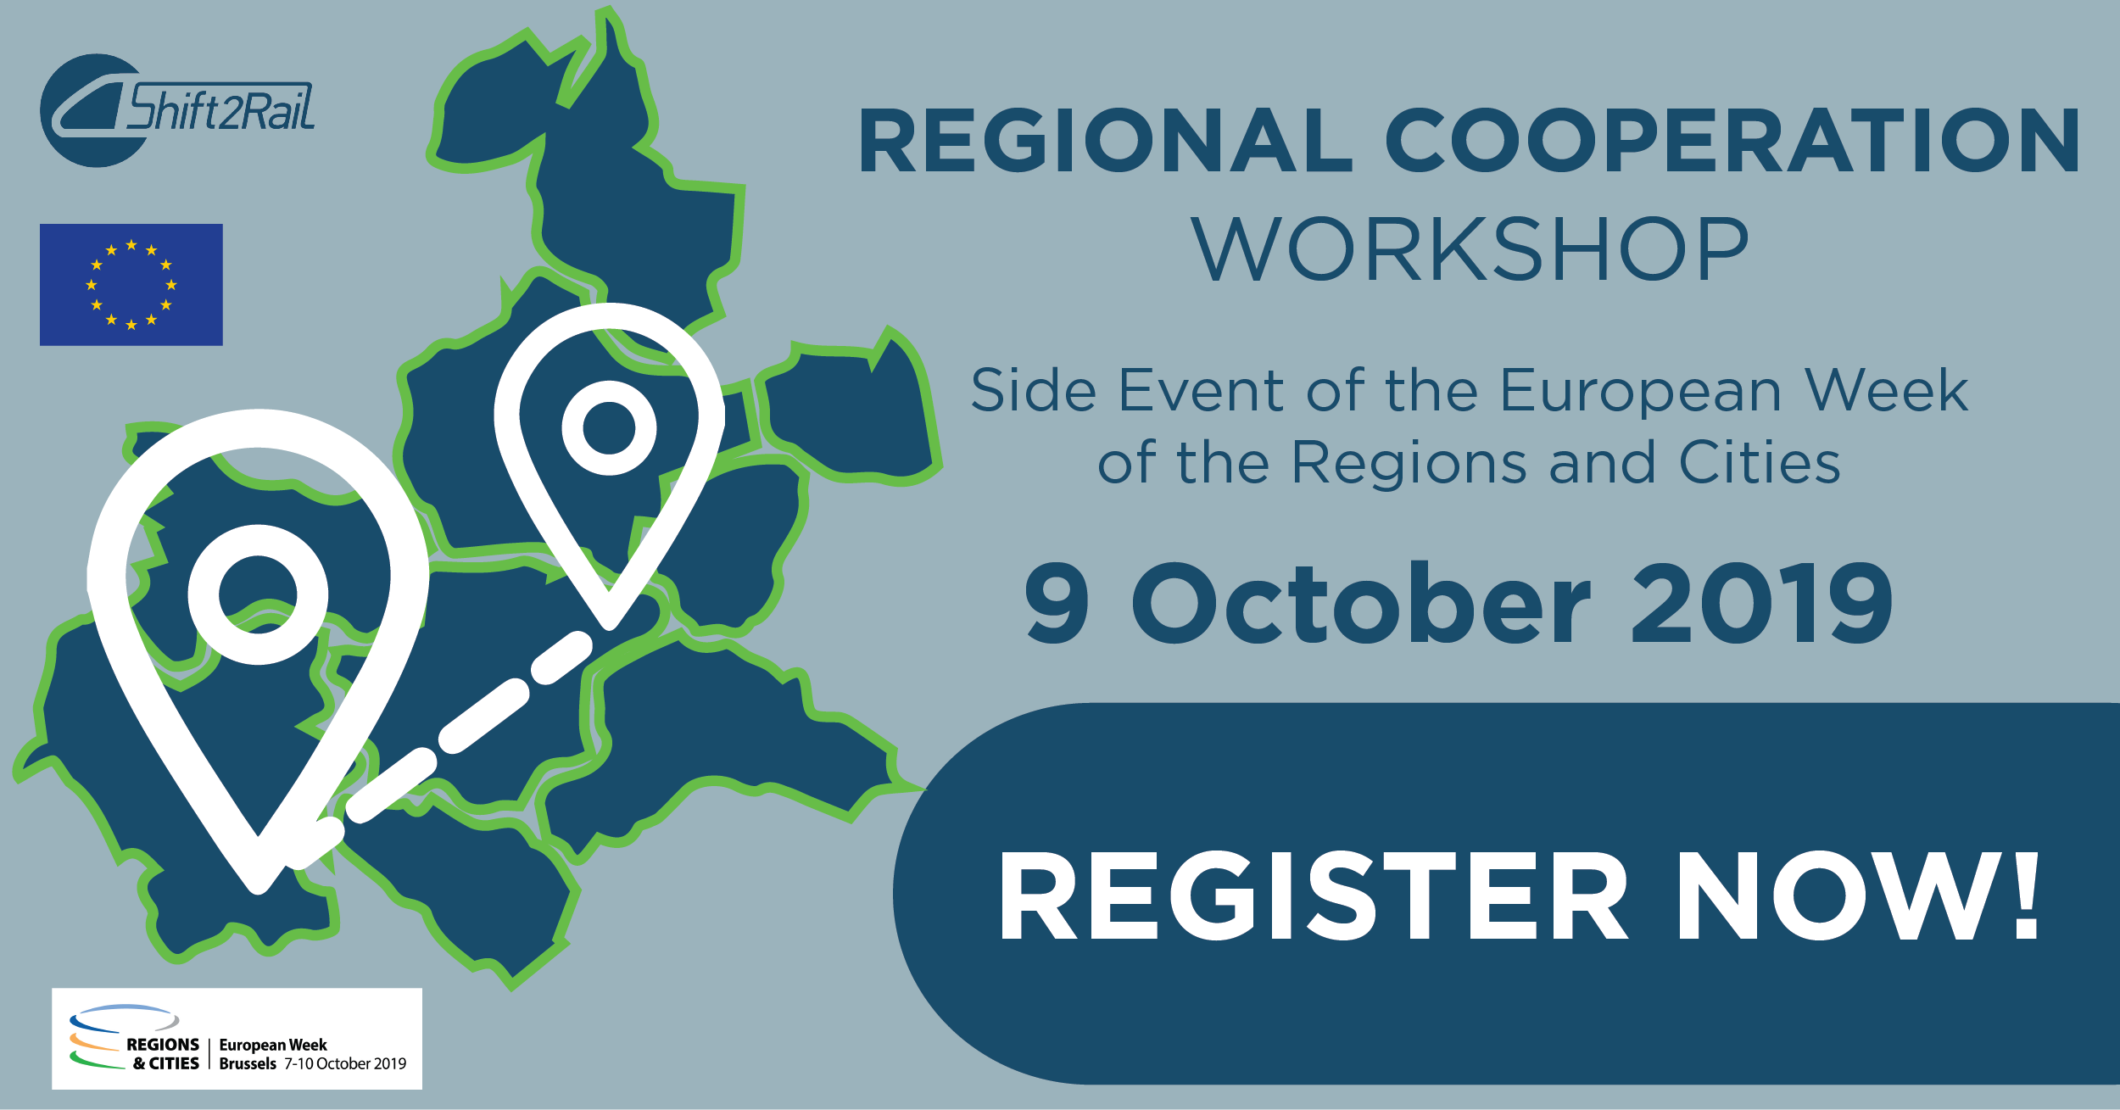](https://ec.europa.eu/eusurvey/runner/WorkshopOnRegionalCooperation)

Following a report published on 20 May by the European Commission’s Joint Research Centre inviting Joint Undertakings to explore different possibilities for collaboration with European Structural and Investment Funds, Shift2Rail decided to organize a workshop bringing together representatives from the regions, the European Commission and Parliament as well as Joint Undertakings to discuss possibilities for collaboration. Shift2Rail Regional Cooperation Workshop on 9 October will offer stakeholders the possibility to share expertise and success stories as well as to discuss possibilities to further enhance cooperation. In addition, the workshop will offer regional representatives the possibility to have bilateral meetings with Shift2Rail’s management allowing for collaboration opportunities to be discussed in more detail.

Shift2Rail will organize the Regional Cooperation Workshop as a side event of the European Week of the Regions and Cities which takes place from 7-10 October in Brussels. The European Week of Regions and Cities is expected to bring together around 6,000 visitors from more than 70 countries. See more information about the Week of the Regions and Cities here.

The Shift2Rail Regional Cooperation Workshop will take place in the White Atrium Building at Avenue de la Toison d’Or 56-60 from 12.30 to 17.30.